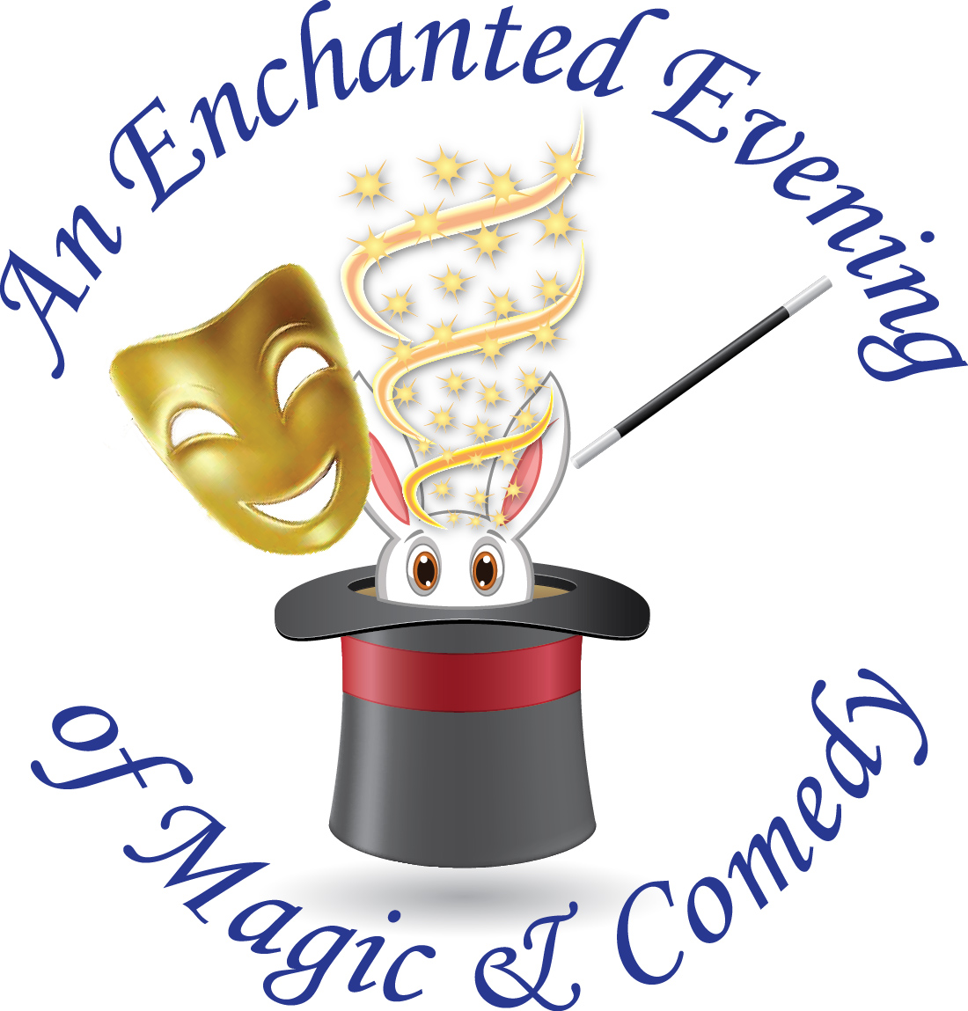

Vocational Visions Nets $100,000 at Enchanted Evening Fundraiser and Honors ABM Industries

Irvine, Calif. (April 21, 2015) – Over 300 guests helped Vocational Visions reach their
fundraising goal of $100,000 at the organization’s 12th annual Enchanted Evening fundraiser on
Saturday, April 18. Chaired by community leader and Vocational Visions’ board member Hilary
Hurt, the event was held at the Irvine Marriott Hotel with the theme, “An Enchanted Evening of
Magic & Comedy.”

ABM Industries was awarded with Vocational Visions’ Employer of the Year award. Regional
Director Jeffrey Leonard accepted the award on behalf of ABM and shared that ABM has
employed ten clients through Vocational Visions’ Supported Employment and Direct
Placement programs since March 2014. ABM is one of the largest facility management services
providers in the U.S. with nearly 100,000 employees nationwide.

The festive evening began with an expansive silent auction and cocktail reception. Volunteer magicians and Magic Castle members Randy Gastreich, Victor Globa and John Tonsick delighted guests with their strolling magic during the initial reception. World Champion Magician Johnny Ace Palmer topped off the evening with a spectacular magic show which included Vocational Visions participants.

Clint Hufft served as both emcee and auctioneer for the live auction which included an
Anaheim Ducks jersey signed by all current players, a Corum Admiral’s Cup Challenger
watch valued at $14,000, and a four-hour entertainment package from Johnny Ace Palmer.

The evening highlight was a special musical performance by Vocational Visions participants.

For more information about Vocational Visions, call 949.837.7280, ext. 214 or visit www.vocationalvisions.org.

About Vocational Visions
Since 1974, Vocational Visions has provided vocational, economic and social services to Orange County adults with intellectual/developmental and other disabilities. The nonprofit organization has eight comprehensive programs that serve more than 500 men and women by providing pathways to employment, life-long learning, and community inclusion.
###

